Git is a version control system used by developers to track changes in their code. It helps you save different versions of your project, collaborate with others, and go back to older versions if something goes wrong.

A repository is a place where your project lives, along with all its files, folders, and the complete history of changes. It’s used in version control systems like Git to manage code.
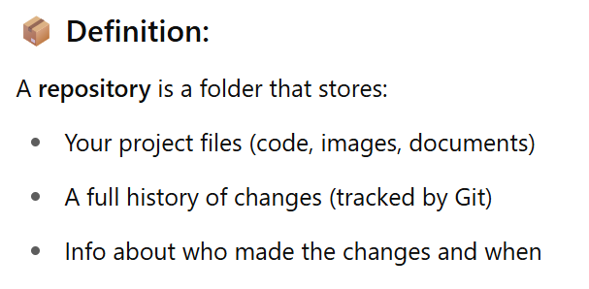
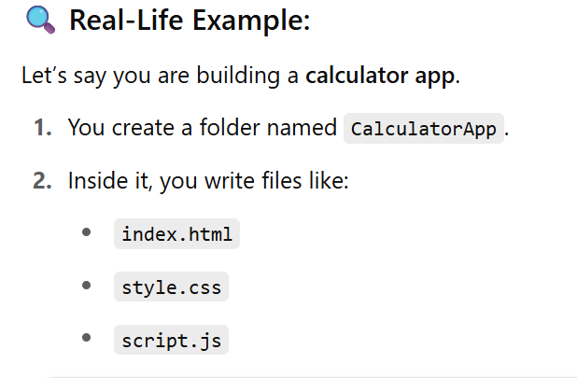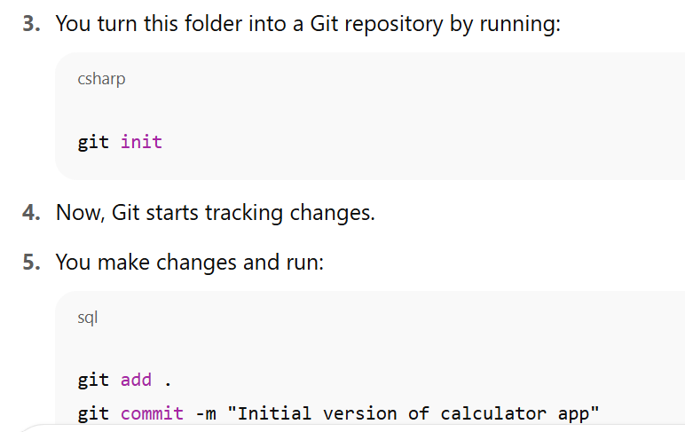
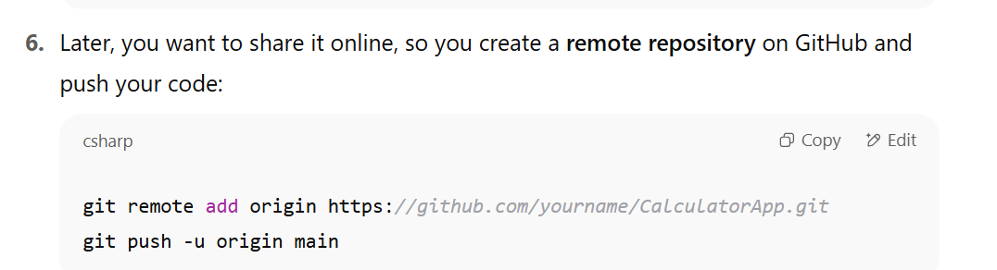

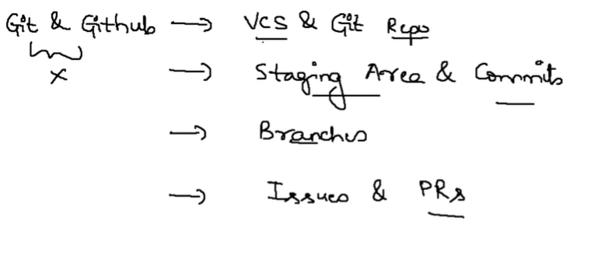
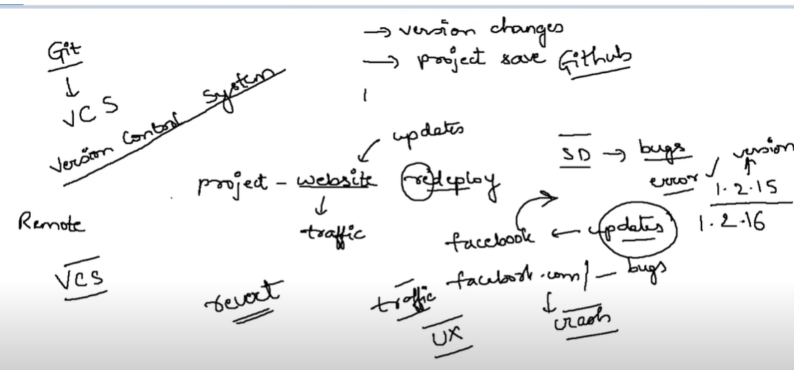
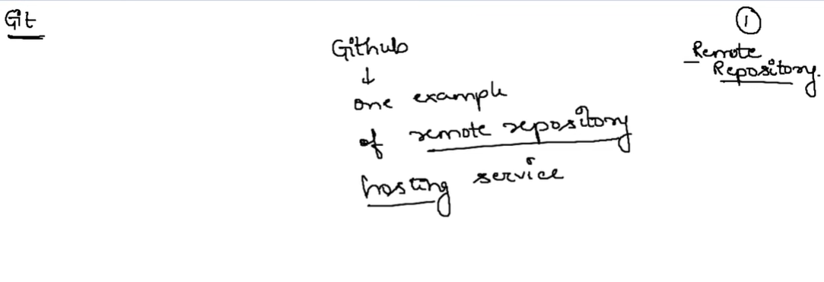

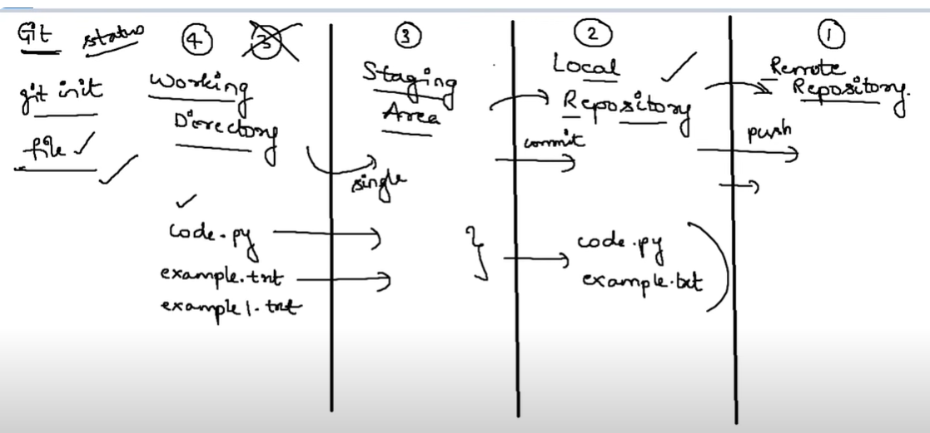

What is HTML?
- HTML stands for Hyper Text Markup Language
- HTML is the standard markup language for creating Web pages
- HTML describes the structure of a Web page
- HTML consists of a series of elements
- HTML elements tell the browser how to display the content
- HTML elements label pieces of content such as "this is a heading", "this is a paragraph", "this is a link", etc.
Example:
<!DOCTYPE html>
<html>
<head>
<title>Page Title</title>
</head>
<body>
<h1>My First Heading</h1>
<p>My first paragraph.</p>

</body>
</html>

Example Explained
- The <!DOCTYPE html> declaration defines that this document is an HTML5 document
- The <html> element is the root element of an HTML page
- The <head> element contains meta information about the HTML page
- The <title> element specifies a title for the HTML page (which is shown in the browser's title bar or in the page's tab)
- The <body> element defines the document's body, and is a container for all the visible contents, such as headings, paragraphs, images, hyperlinks, tables, lists, etc.
- The <h1> element defines a large heading
- The <p> element defines a paragraph

What is an HTML Element?
An HTML element is defined by a start tag, some content, and an end tag:
<tagname> Content goes here... </tagname>
The HTML element is everything from the start tag to the end tag:
<h1>My First Heading</h1>
<p>My first paragraph.</p>

HTML Page Structure
Below is a visualization of an HTML page structure:
<html>
<head>
<title>Page title</title>
</head>
<body>
<h1>This is a heading</h1>
<p>This is a paragraph.</p>
<p>This is another paragraph.</p>
</body>
</html>
A simple text editor is all you need to learn HTML.

Learn HTML Using Notepad or TextEdit
Web pages can be created and modified by using professional HTML editors.
However, for learning HTML we recommend a simple text editor like Notepad (PC) or TextEdit (Mac).
We believe that using a simple text editor is a good way to learn HTML.
Follow the steps below to create your first web page with Notepad or TextEdit.

Step 1: Open Notepad (PC)
Windows 8 or later:
Open the Start Screen (the window symbol at the bottom left on your screen). Type Notepad.
Windows 7 or earlier:
Open Start > Programs > Accessories > Notepad

Step 1: Open TextEdit (Mac)
Open Finder > Applications > TextEdit
Also change some preferences to get the application to save files correctly. In Preferences > Format > choose "Plain Text"
Then under "Open and Save", check the box that says "Display HTML files as HTML code instead of formatted text".
Then open a new document to place the code.

Step 2: Write Some HTML
Write or copy the following HTML code into Notepad:
<!DOCTYPE html>
<html>
<body>
<h1>My First Heading</h1>
<p>My first paragraph.</p>
</body>
</html>
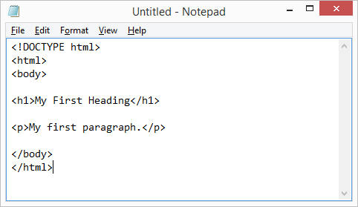

Step 3: Save the HTML Page
Save the file on your computer. Select File > Save as in the Notepad menu.
Name the file "index.htm" and set the encoding to UTF-8 (which is the preferred encoding for HTML files).
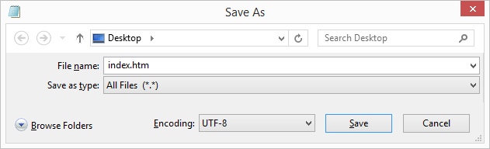
Tip: You can use either .htm or .html as file extension. There is no difference; it is up to you.

Step 4: View the HTML Page in Your Browser
Open the saved HTML file in your favorite browser (double click on the file, or right-click - and choose "Open with").
The result will look much like this:
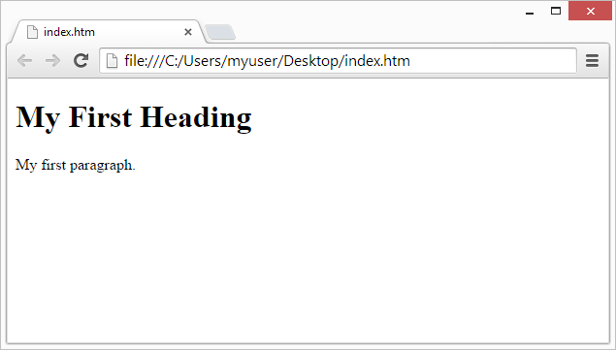
HTML attributes provide additional information about HTML elements.

HTML Attributes
- All HTML elements can have attributes
- Attributes provide additional information about elements
- Attributes are always specified in the start tag
- Attributes usually come in name/value pairs like: name="value"

The href Attribute
The <a> tag defines a hyperlink. The href attribute specifies the URL of the page the link goes to:

Example
<a href="https://www.w3schools.com">Visit W3Schools</a>
You will learn more about links in our HTML Links chapter.

The src Attribute
The <img> tag is used to embed an image in an HTML page. The src attribute specifies the path to the image to be displayed:

Example
<img src="img_girl.jpg">
There are two ways to specify the URL in the src attribute:
1. Absolute URL - Links to an external image that is hosted on another website. Example: src="https://www.w3schools.com/images/img_girl.jpg".
Notes: External images might be under copyright. If you do not get permission to use it, you may be in violation of copyright laws. In addition, you cannot control external images; it can suddenly be removed or changed.
2. Relative URL - Links to an image that is hosted within the website. Here, the URL does not include the domain name. If the URL begins without a slash, it will be relative to the current page. Example: src="img_girl.jpg". If the URL begins with a slash, it will be relative to the domain. Example: src="/images/img_girl.jpg".
Tip: It is almost always best to use relative URLs. They will not break if you change domain.

The width and height Attributes
The <img> tag should also contain the width and height attributes, which specify the width and height of the image (in pixels):

Example
<img src="img_girl.jpg" width="500" height="600">

The alt Attribute
The required alt attribute for the <img> tag specifies an alternate text for an image, if the image for some reason cannot be displayed. This can be due to a slow connection, or an error in the src attribute, or if the user uses a screen reader.

Example
<img src="img_girl.jpg" alt="Girl with a jacket">

Example
See what happens if we try to display an image that does not exist:
<img src="img_typo.jpg" alt="Girl with a jacket">

Example programs:

1.<!DOCTYPE html>
<html>
<body>

<h1>My First Heading</h1>
<p>My first paragraph.</p>

</body>
</html>

The href Attribute
The <a> tag defines a hyperlink. The href attribute specifies the URL of the page the link goes to:

2.<!DOCTYPE html>
<html>
<body>

<h2>The href Attribute</h2>

<p>HTML links are defined with the a tag. The link address is specified in the href attribute:</p>

<a href="https://www.w3schools.com">Visit W3Schools</a>

</body>
</html>

The src Attribute
The <img> tag is used to embed an image in an HTML page. The src attribute specifies the path to the image to be displayed:

3.<!DOCTYPE html>
<html>
<body>

<h2>The src Attribute</h2>
<p>HTML images are defined with the img tag, and the filename of the image source is specified in the src attribute:</p>

<img src="img_girl.jpg" width="500" height="600">

</body>
</html>

The style Attribute
The style attribute is used to add styles to an element, such as color, font, size, and more.

4.<!DOCTYPE html>
<html>
<body>

<h2>The style Attribute</h2>
<p>The style attribute is used to add styles to an element, such as color:</p>

<p style="color:red;">This is a red paragraph.</p>

</body>
</html>

The lang Attribute
You should always include the lang attribute inside the <html> tag, to declare the language of the Web page. This is meant to assist search engines and browsers.
The following example specifies English as the language:
<!DOCTYPE html>
<html lang="en">
<body>
...
</body>
</html>
<!DOCTYPE html>
<html lang="en-US">
<body>
...
</body>
</html>

HTML Headings
HTML headings are defined with the <h1> to <h6> tags.
<h1> defines the most important heading. <h6> defines the least important heading.

6.<!DOCTYPE html>
<html>
<body>

<h1>Heading 1</h1>
<h2>Heading 2</h2>
<h3>Heading 3</h3>
<h4>Heading 4</h4>
<h5>Heading 5</h5>
<h6>Heading 6</h6>

</body>
</html>

The HTML style attribute is used to add styles to an element, such as color, font, size, and more.

7.<!DOCTYPE html>
<html>
<body>

<p>I am normal</p>
<p style="color:red;">I am red</p>
<p style="color:blue;">I am blue</p>
<p style="font-size:50px;">I am big</p>

</body>
</html>

Background Color
The CSS background-color property defines the background color for an HTML element.
8.<!DOCTYPE html>
<html>
<body style="background-color:powderblue;">

<h1>This is a heading</h1>
<p>This is a paragraph.</p>

</body>
</html>

Example
Set background color for two different elements:

<!DOCTYPE html>
<html>
<body>

<h1 style="background-color:powderblue;">This is a heading</h1>
<p style="background-color:tomato;">This is a paragraph.</p>

</body>
</html>

HTML Formatting Elements
Formatting elements were designed to display special types of text:
- <b> - Bold text
- <strong> - Important text
- <i> - Italic text
- <em> - Emphasized text
- <mark> - Marked text
- <small> - Smaller text
- <del> - Deleted text
- <ins> - Inserted text
- <sub> - Subscript text
- <sup> - Superscript text
9.<!DOCTYPE html>
<html>
<body>

<p><b>This text is bold</b></p>
<p><i>This text is italic</i></p>
<p>This is<sub> subscript</sub> and <sup>superscript</sup></p>

</body>
</html>

Here’s a clean and structured HTML code version of your resume:

<!DOCTYPE html>
<html lang="en">
<head>
<meta charset="UTF-8" />
<meta name="viewport" content="width=device-width, initial-scale=1.0"/>
<title>D Swathi - Resume</title>
<style>
body {
font-family: Arial, sans-serif;
margin: 40px;
background-color: #f9f9f9;
color: #333;
}
h1, h2 {
color: #2c3e50;
}
.section {
margin-bottom: 25px;
}
.info, .education, .skills, .projects, .hobbies, .declaration {
background-color: #fff;
padding: 20px;
border-radius: 8px;
box-shadow: 0 2px 6px rgba(0,0,0,0.1);
}
ul {
padding-left: 20px;
}
</style>
</head>
<body>

<h1>D Swathi</h1>
<div class="info section">
<p><strong>Email:</strong> swduggi@gmail.com</p>
<p><strong>Phone:</strong> +91-9912038578</p>
<p><strong>Location:</strong> Hyderabad, India</p>
</div>

<div class="section">
<h2>Career Objective</h2>
<div class="career-objective">
<p>To secure a responsible career opportunity to fully utilize my training and skills, while making a significant contribution to the success of the organization.</p>
</div>
</div>

<div class="education section">
<h2>Education</h2>
<ul>
<li><strong>B.Tech in Computer Science</strong> – KL University (2024 - 2028), CGPA: 9.7</li>
<li><strong>Intermediate (MPC)</strong> – Aspire Junior College (2022 - 2024), Percentage: 95%</li>
<li><strong>SSC</strong> – Sreenidhi Global School (2022), CGPA: 9.7</li>
</ul>
</div>

<div class="skills section">
<h2>Skills</h2>
<p><strong>Programming Languages:</strong> Python, C, HTML, Java</p>
<p><strong>Tools & Platforms:</strong> Git, VS Code, Eclipse, Excel</p>
<p><strong>Soft Skills:</strong> Communication, Leadership, Time Management</p>
</div>

<div class="projects section">
<h2>Projects</h2>
<ul>
<li><strong>Diseases Detector using Drones:</strong> Detected crop health and diseases through aerial drone surveillance.</li>
<li><strong>Pet Feeder using IoT:</strong> Automated pet food dispenser controlled via IoT app.</li>
<li><strong>Morse Code Detector:</strong> Used Arduino and LCD to decode Morse signals.</li>
</ul>
</div>

<div class="hobbies section">
<h2>Hobbies</h2>
<p>Editing, Watching Cricket, Travelling</p>
</div>

<div class="declaration section">
<h2>Declaration</h2>
<p>I hereby declare that the above information is true to the best of my knowledge and belief.</p>
<br>
<p><strong>Place:</strong> Hyderabad</p>
<p><strong>Date:</strong> 19/07/2025</p>
<br>
<p><strong>Signature:</strong> D Swathi</p>
</div>

</body>
</html>

